|  |  |  |  |  |  |  |
| --- | --- | --- | --- | --- | --- | --- |
| **Practicum Final Exam – Even Semester Year 2021/2022** | | | | | | |
| **Subject** | | | **ISYS6169 – Database Systems** | | |  |
| **Class** | **:** | **BA05** | | **Start Date** | **: 22 June 2021** |
| **Lecturer** | **:** | **D4767 – Harkat Christian Zamasi, S.Kom., M.M.S.I.** | | **Start Time** | **: 07.20** |
| **End Date** | **: 22 June 2021** |
| **End Time** | **: 09.20** |

**PERATURAN UJIAN:**

*Exam Regulations:*

* Mahasiswa tidak diperbolehkan berdiskusi dan/atau bekerja sama dengan peserta ujian lainnya

*Student is not allowed to discuss and/or work together with other exam participants*

* Mahasiswa tidak diperbolehkan untuk membuka dan menyalin dari **BUKU** atau **CATATAN**, **VIDEO** dari pengajar (recording kelas, VBL, Youtube, dsb) dan **REFERENSI** lainnya

*Student isn't allowed to open and copy from any resources such as notes, videos (class recording, VBL, Youtube, etc) and other references*

* Mahasiswa tidak diperbolehkan membuka dan menyalin jawaban dari internet (google, stackoverflow, dsb)

*Student isn't allowed to open and copy answer from the internet (google, stackoverflow, etc)*

* Asisten **BERHAK** memberi nilai 0 **(NOL)** bagi peserta ujian yang melakukan segala bentuk kecurangan

*Assistant is able to give 0 (ZERO) score for exam participant who does any cheating actions*

* Kumpulkan jawaban tepat pada waktunya, apabila terlambat mengumpulkan maka jawaban tidak akan dikoreksi dan nilai mahasiswa adalah 0

*Submit the answer on time, if not, then the answer will not be checked, and the students will receive 0 (ZERO)*

* Bila Anda tidak membaca peraturan ini, maka Anda dianggap telah membaca dan menyetujuinya

*If you have missed to read these regulations, so you are considered to have read and agreed on it*

**SOFTWARE YANG DIGUNAKAN:**

*Software will be used:*

* SQL Server Management Studio 18.5.1
* SQL Server Developer 2019

**FILE YANG DIKUMPULKAN:**

*File must be collected:*

* SQL

**PERHATIAN!**

*Attention!*

* Bagi yang mengerjakan tidak sesuai dengan soal, maka akan diberikan nilai **NOL (0)**

*For those who do not work in accordance with the exam case will be marked as* ***ZERO (0)***

* Bagi yang mengerjakan tidak sesuai dengan software dan versi yang telah ditetapkan, maka akan tetap dikoreksi dengan software dan versi yang telah ditetapkan

*For those who do not work in accordance with the software and specific version will be corrected by the predefined software and version*

* Kompres semua jawaban yang akan diunggah. Pastikan format pengumpulan nama file dan ekstensi sesuai dengan format berikut: **[NIM]-[NAMA].zip**

*Compress all file that will be uploaded. Make sure the format for collecting file name and extension according to the following format:* ***[NIM]-[NAME].zip***

**Tabel Relasional**

*Relational Table*

**Bluejack Bioskop**

**Soal**

*Case*

1. Display **FilmId**, **FilmName**, and **FilmShowTime** for every film whose name is **more** **than** **15** **characters**.

(**len**)

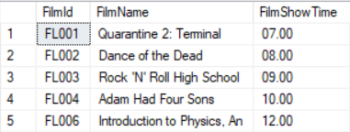

1. Display **TransactionId**, **CustomerName (lower character format)**, and **TransactionDate** for every transaction which **occurs in** **March**.

(**lower, datename, month, join**)

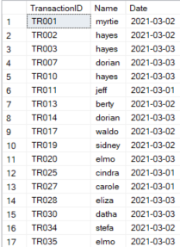

1. Display **Title** (obtained by **FilmName**), **Price** (obtained by adding ‘IDR’ in front of **FilmPriceTicket** and ‘,-’ behind **FilmPriceTicket**) and **Gross Profit** (obtained from **total of quantity** **times** **FilmPriceTicket** and by adding ‘IDR’ in front of **Gross Profit** and ‘,-’ behind **Gross Profit**) for every Film which name is **more than one word.**

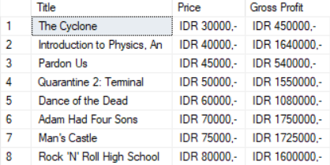

1. Display **CustomerName**, **TransactionId**, **TransactionDate**, **Total of** **Film** (obtained from the **total number of Film**), **Total of** **Quantity** (obtained from the **total Quantity**) for every Customer whose **born in even year**. Then, **combine** with **CustomerName**, **TransactionId**, **TransactionDate**, **Total** **of** **Film** (obtained from the **total number of Film**), **Total of Quantity** (obtained from the **total Quantity**) for every Customer whose **name is more than 7 characters**. **Sort** the data based on **Total of Quantity in descending** order.

(**convert, sum, cast, order by, year, len**)

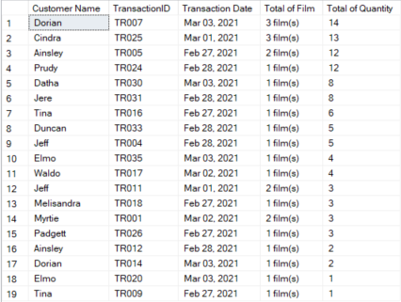

1. **Display** **CustomerName**, **CustomerAddress**, **CustomerEmail**, **CustomerDOB** for every customer who has transaction in **February** and purchase films whose **genre are ‘Action’**.

(**convert, month, in**)

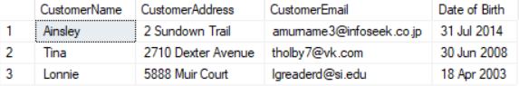

1. Display **CustomerID**, **CustomerName**, **CustomerPhone**, and **CustomerEmail** for every customer who has purchasedaticket **more than** the **average** **ticket** **purchase** and Customer Name **contains ‘a’ character.**

(**alias subquery, avg, like, order by, distinct**)

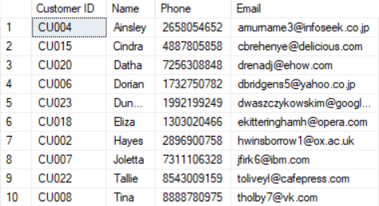

1. Create a **view** named **‘ContractRoleView’** to display **StaffID** (Obtained by **getting** **last** **character** of **StaffID** and **adding** **'Staff'** **in front of** it), **StaffName**, **StaffAddress**, **StaffRoleName**, and **StaffRoleSalary** for every Staff whose role **is not a ‘Cashier’**.

(**convert, right, create view**)

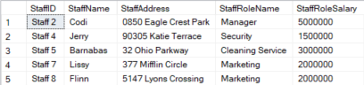

1. Create a view named **‘TransactionDataOfRomanceFilm’** to display **TransactionId**, **Day of Transaction** (obtained from day of **TransactionDate**), **TransactionDate**, **Film Title** (obtained from **FilmName**) and **Total of Quantity** (obtained from the **total of Quantity**) for every transaction which sold Film that **genre** **name** is **‘Romance’**. **Sort** the data based on **Transaction** **Date** in **ascending** order.

(**datename, create view, order by, sum, weekday**)

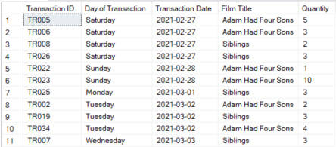

1. Add a **column** named **‘CustomerSocialMedia’** on **Customer** table with **varchar** **(30)** data type and add a **constraint** named **‘CheckCustomerSocialMedia’** to check the **CustomerSocialMedia** is **between** **5** and **25** **characters**.

(**alter table, add, add constraint, between**)

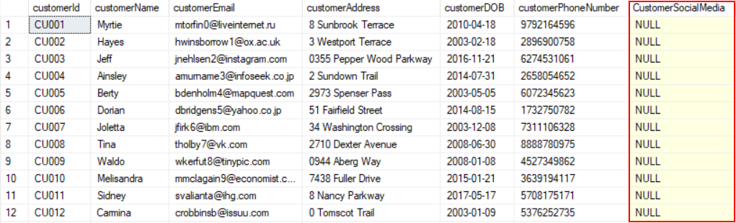

1. **Delete** from **Customer** table data for every customer which **purchase** **a film** **more** **than** **8** **tickets** **in a transaction** and **transaction** which **occurs** in **even** **month**

(**delete, join, month**)

**Before:**

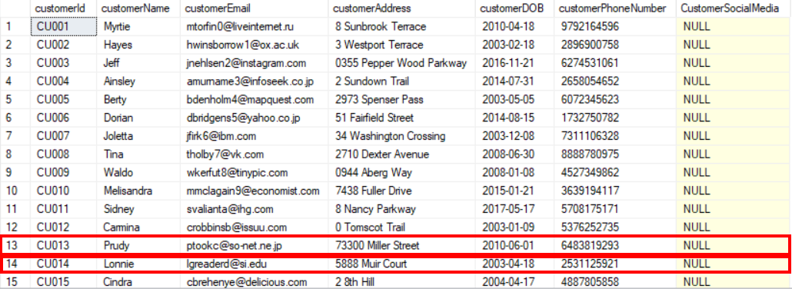

**After:**

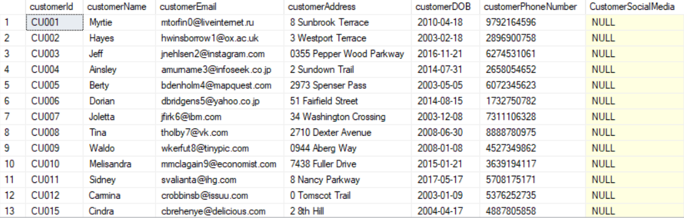

**For question regarding this exam, feel free to ask your teaching assistant!**

**Good Luck 😊**